EXPERIMENT 8
AIM :
POWER SPECTRAL DENSITY (PSD) ANALYSIS OF PHASE MODULATED (PM) SIGNALS USING MATLAB

SOFTWARE REQUIRED :
MATLAB SIMULINK

PROGRAM:
Clc; clear; close all;
Am=1; Ac=5;
Fm=100; fc=1000;
Kp=pi/2;
Fs=20000;
T=0:1/fs:0.04;
M=Am*cos(2*pi*fm*t);
C=Ac*cos(2*pi*fc*t);
Pm=Ac*cos(2*pi*fc*t+kp*m);
N=length(pm);
F=(-N/2:N/2-1)*fs/N;
P=abs(fftshift(fft(pm)/N)).^2;

Subplot(2,2,1);
Plot(t,m);
Title(‘Message Signal’);
Xlabel(‘Time (s)’); ylabel(‘Amplitude’);
Grid on;

Subplot(2,2,2);
Plot(t,c);
Title(‘Carrier Signal’);
Xlabel(‘Time (s)’); ylabel(‘Amplitude’);
Grid on;

Subplot(2,2,3);
Plot(f,P);
Title(‘Power Spectral Density (PSD)’);
Xlabel(‘Frequency (Hz)’); ylabel(‘Power’);
Xlim([-3000 3000]); grid on;

Subplot(2,2,4);
Plot(f,P);
Title(‘Frequency Spectrum of PM Signal’);
Xlabel(‘Frequency (Hz)’); ylabel(‘Magnitude’);
Xlim([-3000 3000]); grid on;

OUTPUT:
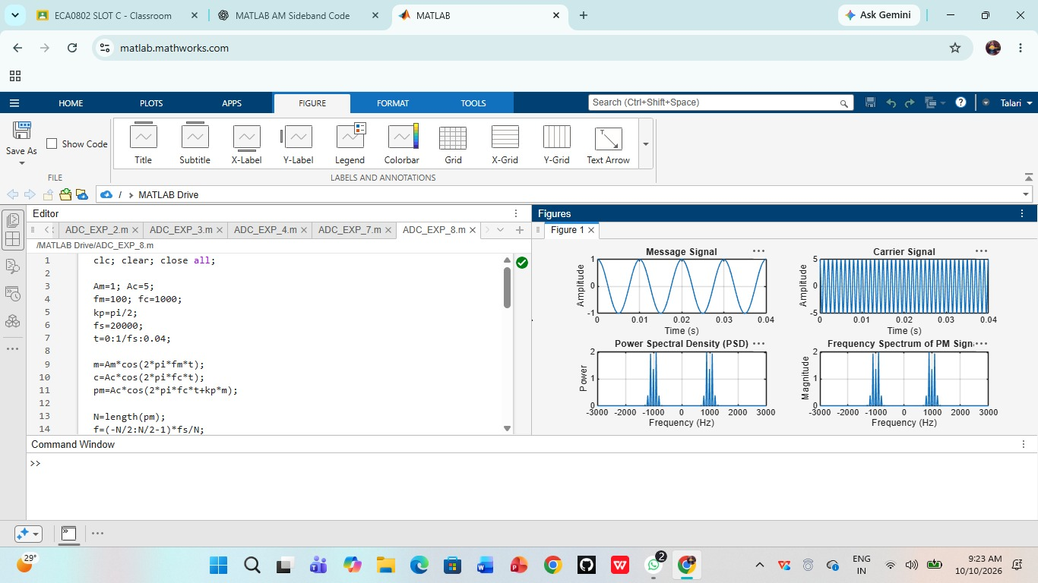

RESULT:
Thus, the Power Spectral Density (PSD) analysis of the phase-modulated signal was successfully performed using MATLAB simulation, and the message signal, carrier signal, PSD, and frequency spectrum plots were obtained.

